
Selection Table 3: Government / Military Destruction Center v2024.9.24
– Budget Above $10,000(Agent Ex-Factory Price)
 | Plan1: YD-PSJ300(3.7K) | Plan2：YD-PSJ350 | Plan3：YD-PSJ500 | Plan4：YD-468CC-HD | Plan5：YD-428ACC-HD | Plan6：YD-428130 | Plan7：YD-500-HD
Pricing USD | Price: $10,071 | Price: $14,102 | Price: $27,396 | Price: $18,160 | Price: $12,219 | Price: $22,511 | Price: $40,835
Entry Image | 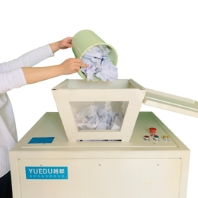 | 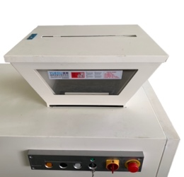 | 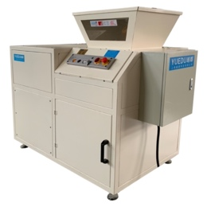 | 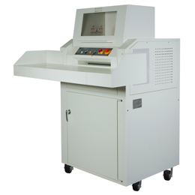 | 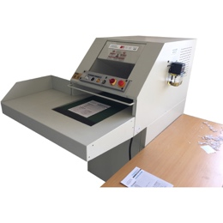 | 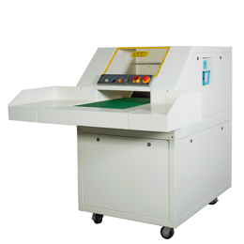 | 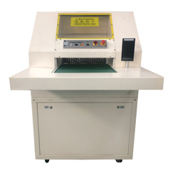
Full  Image | 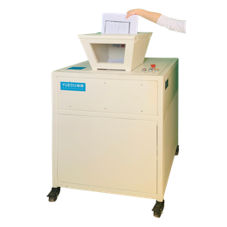 | 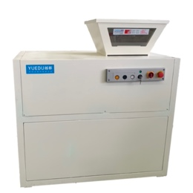 | 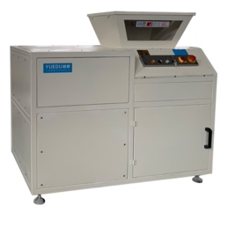 | 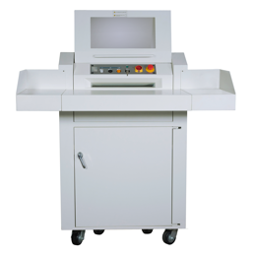 | 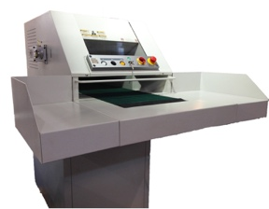 | 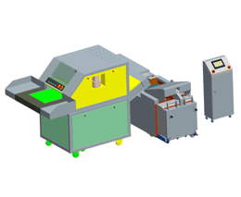 | 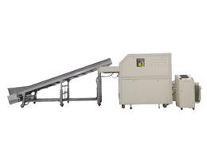
Features | 2 entries  Hard Drives ok | Sleek design,  Hard Drives ok | 2 entries  Hard Drives ok | 2 entries  Small shred size | Belt conveyor entry | Optional conveyor packing system | 500 sheets  conveyor packing
Shredded Size | 10*50mm | 1*5CM | 1*5CM | 5.8*45mm | 5.8*45mm | 5.8*45mm | 7.5*50mm
Sheets | 70-200 | 90-180 | 200-300 | 130 | 60-100 | 100-130 | 300-500
Entry width | 50*38CM  25CM | 51*48CM  35CM | 71*53CM  50CM | 46CM  46CM | 41CM | 46CM | 60CM
Applicable Scenarios | weekly several hours | Daily Shredding: 2-3 hours per day | Design Institute | Design Institute | small printing factories | Printing /Packaging | Government / Military
 | https://youtu.be/VhKA0DnCQ8Y  https://youtu.be/IUsy2eLjN4c | https://youtu.be/Udx2H5R6Ri4  https://youtu.be/263P0IOKHR0 | https://youtu.be/77udmJyKTsQ | https://youtu.be/0r-lzWgT_jQ  https://youtu.be/ZVZToT1b44A | https://youtu.be/GB-Tz5ydTNY  https://youtu.be/e43_cej74q8 | https://youtu.be/JdwMAptwI6U  https://youtu.be/ZRRyfX56Ji4 | https://youtu.be/y4S-BnY2jLE  https://youtube.com/shorts/ckI2b5wgcL4

Customized, e.g. 2 / 5 / 8 / 15 mm etc. It can be customized and developed according to special use needs. 粉碎尺寸可定制，例如：2/5/8/15mm等；可根据特殊的使用需求进行开发。

